

ConsUmer theory and behavioural analysis

SOS 2023



June 27, 2023

sATVIK JAIN

MID-TERM REPORT

Consumer Theory

# Who is a Consumer?

A consumer is an individual who purchases, has the capacity to purchase, goods and services offered for sale by marketing institutions in order to satisfy personal or household needs, wants, or desires.

Since it is quite visible that the reference is made to an individual. Therefore, one should first focus on human behaviour.



# What is Human behaviour?

Human behaviour refers to the process in which the individual reacts with his environment.

Human behaviour encompasses every thought, feeling or action by people. This implies that every thought, motive, sensation and decision that is made every day, is classified as human behaviour.

# Defining Consumer Behaviour

## 1) Belch and belch on consumer behaviour

Belch & Belch provide a link between human behaviour and consumer behaviour, by stating that **consumer behaviour has been defined as the study of human behaviour in a consumer role**. According to Belch and Belch “consumer behaviour is the process and activities people engage in when searching for, selecting, purchasing, using, evaluating and disposing of products and services so as to satisfy their needs and desires”.

## 2) Walters on consumer behaviour

Consumer behaviour, according to Walters, represents specific types of human actions, namely those concerned with the purchase of products and services from marketing organisations.

“We need to accept that consumer behaviour is found in human behaviour.”

## 3) Mowen on consumer behaviour

He provides a different definition by explaining consumer behaviour as the study of the buying units and the exchange processes involved in acquiring, consuming, and disposing of goods, services, experiences, and ideas.

## 4) Schiffman & Kanuk on consumer behaviour

They define consumer behaviour as: "The behaviour that consumers display in searching for, purchasing, using, evaluating, and disposing of products, services, and ideas."

They elaborate on the definition by explaining that consumer behaviour is, therefore, the study of how individuals make decisions to spend their available resources (time, money, effort) on consumption-related items.

# Origin and Importance of Consumer Behaviour

The concept of the development of consumer behaviour is borrowed from other scientific disciplines, such as **psychology** (the study of the individual), **sociology** (the study of groups), **social psychology** (the study of how individuals operate in groups), **anthropology** (the influence of society on the individual) and **economics**.

It is important for any organisation to acknowledge consumer needs as a key to success for both survival and profit generation in a modern economy with multiple products per competitor and multiple competing distribution points.

The importance of understanding consumer behaviour can most probably be summarised in a simple, yet powerful, statement by Assael: "Consumers determine the sales and profits of a firm by their purchasing decisions. As such, their motives and actions determine the economic viability of the firm".

To be a successful seller of products and services (as can be concluded from the statement above), organisations need to understand consumer needs and behaviour and draft their marketing strategies to incorporate such behavioural needs of consumers.

# MODELS OF HUMAN BEHAVIOUR

It is an extremely difficult task to uncover the reasons why people buy, as they are subject to many influences. One reason is that humans are greatly influenced by their psyche, which eventually leads to overt purchase responses.

Human beings can therefore be viewed from many perspectives. If, for instance, human beings are viewed from economic perspective, marketers may attempt to influence them with economic incentives. If, however, viewed from a social theory perspective, marketers may attempt to influence people through appeals to group norms, references and values.

Models of human behaviour provide valuable input to consumer behaviour, since they attempt to provide insights into why human beings, and therefore consumers, rationalise purchase decisions.

To provide a clearer understanding of human behaviour, four models will be discussed together with marketing applications.

The models of human behaviour discussed below are:

* The Marshallian economic model
* The Pavlovian learning model
* The Freudian psychoanalytical model
* The Veblenian social-psychological model

In addition to these four models, the theory of Maslow's hierarchy of needs will be discussed to provide a perspective on the importance of understanding the influence of needs and motivation on consumer behaviour.

## 1) The Marshallian economic model

According to the Marshallian economic model, individual buyers will spend their income on goods that will offer the greatest satisfaction, depending on their taste and the relative prices of goods.

"Marginal-utility" theory of value was formulated independently and almost simultaneously by Walras in Switzerland, Menger in Australia and Jevons and Marshall in England.

Marshall's methods and assumptions have been refined to the Modern Utility Theory, where the economic man maximises his utility and does this by carefully calculating the ''felicific'' consequences of any purchase.

The value of the Marshallian model for the purposes of behavioural science can be viewed from a number of different viewpoints. One point of view is that the model is tautological and therefore neither true nor false. The model is also not very informative because it simply portrays the buyer as acting in his best interest.

A second view is that the model provides logical norms for buyers who want to be "rational", therefore it is a normative rather than a descriptive model of behaviour. The consumer is not likely to employ an economic analysis for all purchases, but is rather selective in using an economic theory. A consumer may therefore not use the economic principles for choosing between two low-cost products but may apply an economic analysis when deciding to purchase a new house or car.

A third view is that economic factors should be included in any comprehensive description of buying behaviour, since economic factors operate, to a greater or lesser extent, in all markets.

The Marshallian model provides a number of useful behavioural hypotheses:

* The first hypothesis offered is that the lower the price of a product, the greater the sales will be for that product.
* A second hypothesis is that the lower the price of a substitute product is than that of a specific product, the greater the sales of the substitute product will be.
* Third, the sales of a product will be higher, provided it is not an inferior product, if the real income is higher.
* The last hypothesis states that greater volumes of sales will follow as promotional expenditure is increased.

As a final comment to the Marshallian model, it can be concluded that economic factors alone cannot explain all variations in the sales and buying process and also that the fundamentals of how brand and product preferences are formed are ignored in this theory. The model offers a useful frame of reference for analysing only a small portion of the consumer's psyche.

## 2) The Veblenian social-psychological model

According to this model, Humans are social creatures. We naturally form connections and belong to different groups like our culture, smaller communities, and the people we interact with face-to-face. These groups shape our behaviour and what we need from others.

According to a theory by Veblen, he suggested that the wealthy leisure class tends to spend a lot of money not based on their actual needs or satisfaction, but rather on seeking prestige and social status. Veblen focused on how people are influenced by others when buying expensive items like cars, houses, and even less expensive things like clothes.

Some people disagree with the model and think it exaggerates things. They say not everyone looks up to the leisure class, and many people want to move up just one level in society. Also, rich people might prefer to spend less on fancy things so they can fit in with others instead of standing out. It's important to know that although Veblen wasn't the first to talk about how social class affects behaviour, his ideas inspired more research.

The marketing application of the Veblenian model is that in order to determine the demand for product, the most important social influences impacting on such product should be determined.

## 3) The Pavlovian learning model

The Pavlovian theory of learning comes from the experiments of a Russian psychologist named Pavlov. He would ring a bell before giving food to a dog. Over time, the dog started to associate the bell with food and would start salivating even if no food was present. This showed that learning happens through association, and a significant part of human behaviour is also influenced in this way.

The result of the research led to a stimulus-response model of human behaviour, based on four central concepts, namely drive, cue, response and reinforcement.

The four central concepts of the Pavlovian theory are discussed below:

a) Drive: In the Pavlovian learning model, drive refers to powerful internal signals that make a person take action. Psychologists recognize two types of drives: primary physiological drives and learned drives. Primary physiological drives are basic needs like hunger, thirst, pain, cold, and sex. Learned drives are influenced by society and include things like competition, fear, and the desire to acquire things.

b) Cue: In the model, a drive is a general urge, and a specific response is triggered only when certain signals are present. These signals are called cues and can be weaker stimuli in the person or the surroundings. Cues determine when, where, and how someone will respond. For example, seeing a coffee advertisement can act as a cue that makes you feel thirsty. Your response will be influenced by this cue as well as other cues, like the time of day and whether or not other drinks are available.

c) Response: A response is how someone reacts to the combination of cues. But it's important to remember that the same combination of cues may not always produce the same response. The response depends on how satisfying or rewarding the experience has been in the past.

d) Reinforcement: When an experience is rewarding, it strengthens the tendency to repeat a certain response. This means that if the same combination of cues reappears, we are likely to give the same response again. However, if a learned response or habit is not reinforced, it may gradually fade away because the strength of the habit decreases over time.

The Pavlovian model doesn't explain everything about how people buy things, but it does help marketers understand consumer behaviour and advertising. For example, when a new product is introduced in a competitive market, the company may try to get people to develop new habits by replacing old ones. They have to convince consumers to try the new product by using strong or weak cues. Strong cues, like giving out samples, can be expensive but work well for loyal customers. It's also important to make sure the product is good so people have a positive experience. Marketers can also use the model to figure out the best cues for popular brands. In advertising, repeating the message is important because people forget easily. It also reinforces their connection to the product when they see the ads again after buying it. To make ads effective, marketers need to appeal to strong desires, like hunger for snacks or wanting to feel important with a fancy car.

## 4) The Freudian psychoanalytical model

Freud assumed that the psychological forces shaping people's behaviour are largely unconscious, resulting in people not being able to fully understand their own motivations.

According to the theory, when a child is born, it has instinctual needs that it can't fulfil on its own. The child soon realizes that it is separate from the world and relies on others to meet its needs. The child tries to get what it needs by using tactics like begging or being demanding.

According to Freudian theory, our mind is made up of different parts. The id represents our strong urges and desires for immediate gratification. It's like the "animal" part of our brain. The ego, on the other hand, is the part that develops as we grow and helps us plan and find ways to satisfy our urges in a conscious way. It acts as a mediator between the id and the superego. The superego is responsible for guiding us to channel our instinctive drives in socially acceptable ways to avoid feelings of guilt and shame. It's like our conscience that tells us what is right and wrong.

For example, if a person is asked why a certain expensive vehicle is bought, the reply may be that the deciding factors were speed, comfort and appearance. At a deeper level, the reasons may include to impress others or to be young again. At an even deeper level, the motive for the purchase may be attributed to an attempt to achieve substitute gratification for unfulfilled sexual urges.

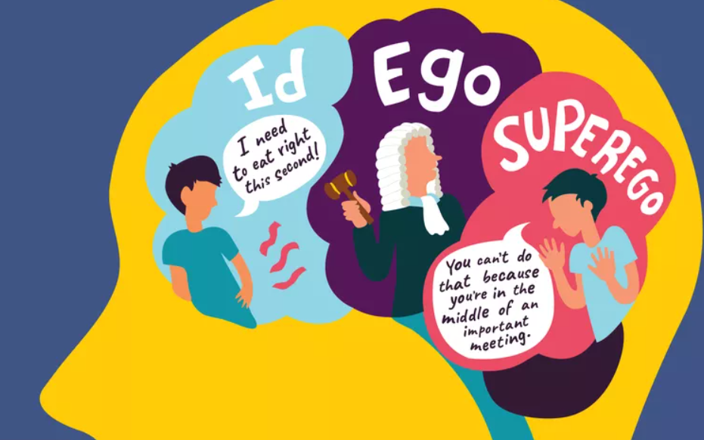

One important marketing implication of the Freudian model is that consumers are motivated by both symbolic and practical reasons when choosing products. For instance, even a simple change in the shape of a bar of soap, like going from square to round, can have a sexual connotation that influences consumer preferences. Another example is an advertisement for a cake mix that portrays easy preparation, which may make some housewives feel guilty because it suggests they are taking shortcuts instead of putting in effort. So, marketers need to consider the deeper meanings and emotions associated with their products to effectively appeal to consumers.

THEORY OF CONSUMER BEHAVIOUR



Consumers are individuals or households who decide what goods to buy and in what amounts. The study of consumer behaviour asks questions like why people choose certain products, how they decide how much to buy, and what their goal is when spending money. Understanding consumer behaviour helps us understand market demand. It starts by looking at consumer preferences and tastes, which can be measured using concepts like utility or indifference curves.

# Economic Theories

Economists have developed theories to explain how consumers behave when making purchases. These theories suggest that consumers are rational and aim to get the most value for their money. Price is a significant factor influencing consumer decisions, and they often choose the product with the lowest price among competing options.

Several economic factors affect how consumers spend their income. People typically don't spend all of their income and allocate a portion for personal consumption and saving. Changes in income, inflation, family size, and future income expectations can all impact consumer spending patterns. The availability of consumer credit also plays a role in influencing consumer behaviour. The use of instalment credit allows consumers to have greater purchasing power beyond their current income.

Fluctuations in income can have a significant impact on consumer purchases, especially for durable goods. Consumers are more willing to take on instalment debt when their income is rising, but they are more hesitant to incur additional debt when their income is declining.

Overall, there are various economic theories that explain different aspects of consumer buying behaviour. These theories help us understand how consumers make decisions and allocate their resources.

Consumer has to decide where to spend his income on, Economist call this the problem of choice. Most consumer wants a combination of goods that give them maximum satisfaction. This combination often depends on the income of the customer and the price of the goods.

There are two approaches that explains consumer behaviour:

1. Cardinal Utility Analysis
2. Ordinal Utility Analysis

Cardinal Utility Analysis attracted criticism as it believed that utility is quantitatively measurable, this led to the development of Ordinal Utility Analysis.

# Cardinal Utility Theory

Cardinal utility analysis assumes that level of utility can be expressed in numbers. For example, one can measure the utility derived from a shirt and say, this shirt gives me 50 units of utility.

Total Utility

The sum of the utilities obtained from consuming each commodity up to a given point.

## Marginal Utility

The additional utility gained upon consumption of an additional unit of a commodity

## Law of diminishing Marginal Utility

|  |  |  |
| --- | --- | --- |
| Quantity of a good consumed | Total Utility | Marginal Utility |
| 0 | 0 | 0 |
| 1 | 4 | 4 |
| 2 | 7 | 3 |
| 3 | 9 | 2 |
| 4 | 10 | 1 |
| 5 | 10 | 0 |

As the amount consumed of a good increase, the marginal utility of the good tends to decrease known as the law of diminishing marginal utility.

The above table shows that consuming the first unit of an item gives the consumer a utility of say 4 unit. In this instance both the total and marginal utility is 4. The second unit of the item will also give him some utility, but not same as the first one as his urge reduces. After consuming the second unit, his total utility is 7 and the marginal utility is 3 as he gets 3 units of satisfaction from the second unit. As he consumes more of the same item, marginal utility gradually drops. This pattern will continue through the third and fourth item until finally, by the fifth perhaps, fails to offer any satisfaction whatsoever.

Law of diminishing Marginal Utility can be easily understood by a wonderful illustration from [TED-Ed by Akshita Agarwal](https://www.ted.com/talks/akshita_agarwal_the_paradox_of_value).

.

Water-Diamond Paradox

Imagine you are on a game show, and you can choose between two prizes a diamond or a bottle of water.

It is an easy choice- the diamonds are clearly more valuable. Now imagine being given the same choice again, only this time you are not on a game show but dehydrated in the desert after wandering for days. Do you choose differently? Why? Aren’t diamonds still more valuable!

This is the paradox of value famously described by pioneering economist Adam Smith. Defining value is not a simple thing at all. On the game show, you were thinking about each item’s exchange value- what you could get from them at a later time, but in an emergency like the desert scenario what matters far more is their use-value- how helpful they are in your current situation and because we only get to choose one of the options we also have to consider its opportunity cost or what we lose by giving up the other choice.

After all, it won’t matter how much you could make by selling the diamond if you never make it out of the desert. Most modern economists deal with the paradox of value by attempting to unify these considerations under the concept of utility- how well something satisfies a person’s wants or needs.

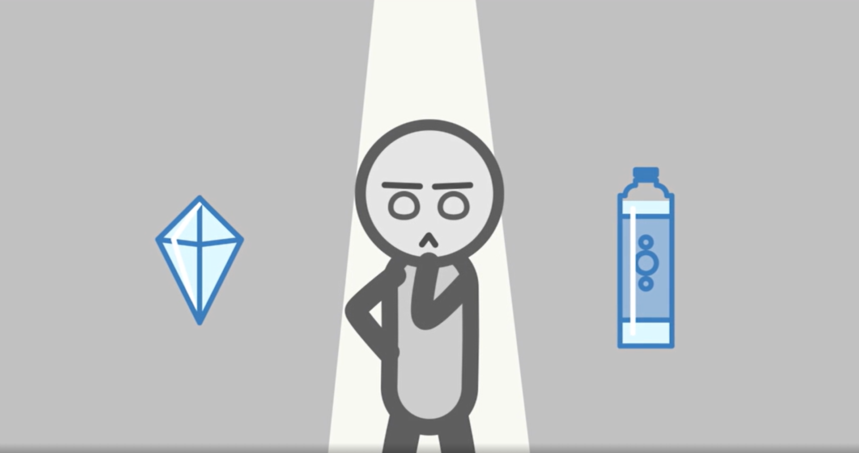

The utility can apply to anything from basic needs like food to pleasure of hearing a favourite song. This will naturally vary for different people and circumstances. A market economy provides us with an easy way to track utility. Put simply the utility something has to you is reflected by how much you would be willing to pay for it.

Now imagine yourself back in the desert, only this time you get offered a new diamond or a fresh bottle of water every 5 minutes. If you are like most people, you will first choose enough water to last the trip and as many diamonds as you can carry. This is because of something called marginal utility of it means that when you choose between diamonds and water you compare utility of every additional water bottle every additional diamond. And you do this each time an offer is made; the first bottle of water to you is worth more than any amount of diamond but eventually, you have all the water you need. After a while, every additional bottle becomes a burden. That’s when you start choosing diamonds over the water.

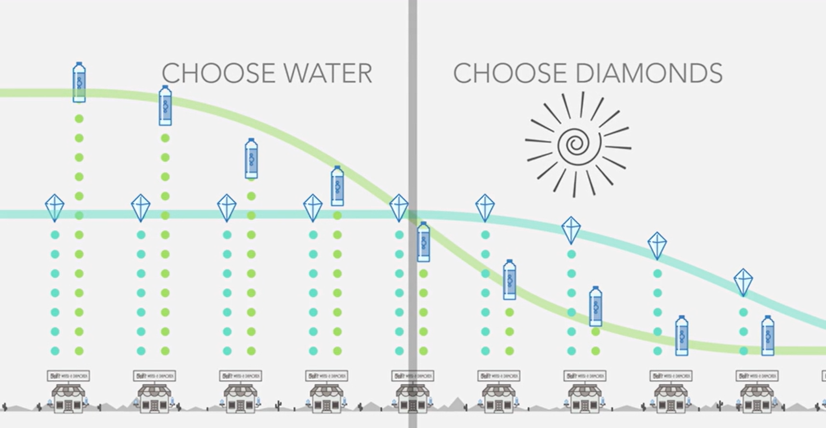

## Relation between Total and Marginal Utility

|  |  |  |
| --- | --- | --- |
| Quantity of a good consumed | Total Utility | Marginal Utility |
| 0 | 0 | 0 |
| 1 | 4 | 4 |
| 2 | 7 | 3 |
| 3 | 9 | 2 |
| 4 | 10 | 1 |
| 5 | 10 | 0 |

In general,

**MUn = TUn – TUn-1**,

where subscript n refers to the nth unit of the commodity.

Total utility and marginal utility can also be related in the following way.

**TUn = MU1 + MU2 + … + MUn-1 + MUn**

# Ordinal Utility Analysis

The ordinal utility approach is a school of thought that believes that utility cannot be measured quantitatively, that is, utility is not additive rather it could only be ranked according to preference.

For instance, if a consumer derives 3 utils from the consumption of one unit of commodity X and 12 utils from the consumption of commodity Y, this means that the consumer derives more satisfaction from consuming commodity Y than from commodity X. The ordinal utility theory explains consumer behaviour by the use of indifference curve.

## Indifference curve

An indifference curve is a graph plotted between quantities of either commodity consumed, and is a collection of all bundles of consumption that are equally satisfying to a consumer, i.e., which the consumer is indifferent to.

Indifference curves (I.C.s) have several properties:

* All points on an I.C. offer equal utility.
* Indifference curves are negative sloped.
* The points on one I.C. lying higher than another, offer greater utility than all points on the lower lying I.C.
* Two different I.C.s cannot intersect (can be inferred from the above two)

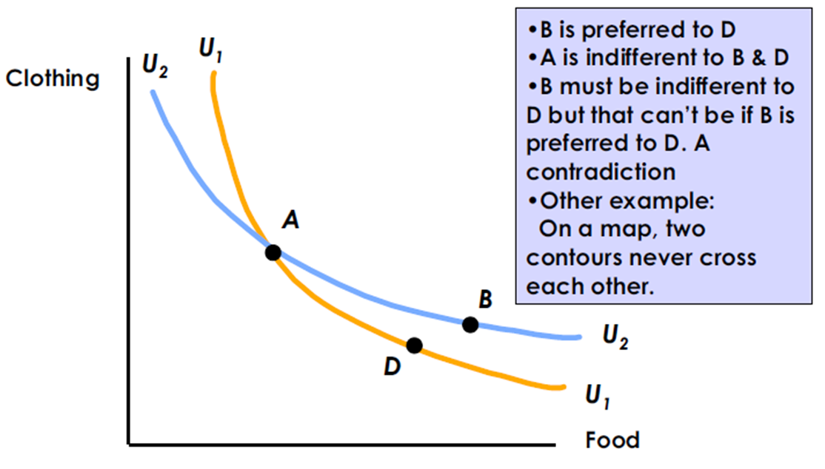

## The marginal rate of substitution

The marginal rate of substitution (MRS) refers to the amount of one good that an individual is willing to give up for an additional unit of another good while maintaining the same level of satisfaction or remaining on the same indifference curve.

Mathematically speaking, the MRS is the slope of the indifference curve plotted between the two said goods. A simple derivation illustrates calculation of MRS given the utility function.

Consider there are two commodities Q1 & Q2 whose quantities are denoted by q1 & q2 respectively. Then the utility function U is a function of two variables q1 & q2.

**U = f (q1, q2)**

Its total differential is

**dU = f1.dq1 + f2.dq2**

Since along the indifference curve, change in utility is zero, therefore,

**dU=0**

i.e. **f1.dq1 + f2.dq2=0**

**- dq2/ dq1 = f1/ f2**

i.e. slope of the indifference curve is equal to the negative of the ratio of the partial derivatives of the utility function. The MRS is thus just the negative of slope.

## The budget constraint

Let us consider a consumer who has only a fixed amount of money (income) to spend on two goods. The prices of the goods are given in the market. The consumer cannot buy any and every combination of the two goods that she may want to consume. The consumption bundles that are available to the consumer depend on the prices of the two goods and the income of the consumer.

Given her fixed income and the prices of the two goods, the consumer can afford to buy only those bundles which cost her less than or equal to her income.

The income and prices of the concerned commodities act as a constraint to the consumer’s ability to consume the desired commodities. Jointly they form a budget constraint and when graphed, it gives the **budget line**.

Assuming our two commodities X and Y with prices Px and Py respectively, if the consumer spends all the income on the two commodities alone,

The budget equation may be written as follows:

**I = XPx + YPy**

Where, I = the income constraint of the consumer. X and Y quantities of commodities X and Y respectively while Px and Py are the respective prices of commodities X and Y.

The consumer can buy any bundle (X1, X2) such that,

**P1X1 + P2X2 ≤ M**

The above inequality is called customer ***budget constraint***. The set of bundles available to the customer is called as ***budget set***.

It is interesting to note that, using ordinal analysis, the point of equilibrium is that point where the budget line is tangent to one of the indifference curves this is because, it lies on the budget line, i.e., while spending maximum money.

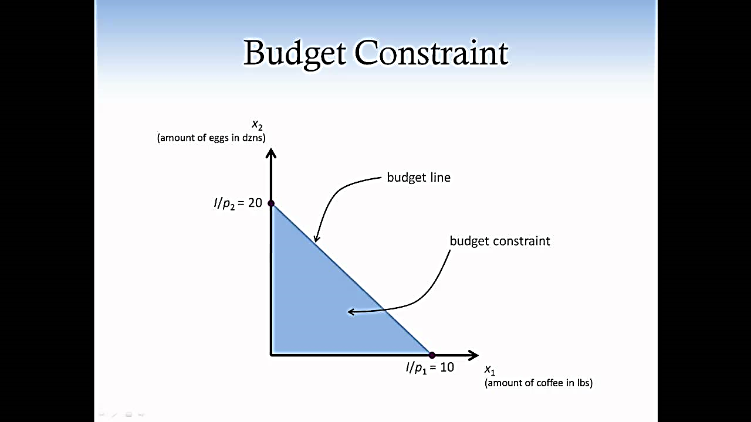

# Top factors that influence **consumer behaviour**

Customer behaviour is shaped by a few key factors.

## **Psychological**

Psychological factors include a person’s attitude, perceptions about a situation, their ability to understand information, what motivates them, their personality and beliefs.

For example, a person who is actively reducing their plastic consumption will buy differently to someone who doesn’t believe in climate change.

## **Personal**

Personal characteristics include age, gender, financial situation, occupation, background, culture and location.

An older person will probably shop in a different way to a younger person, for example with a preference for bricks-and-mortar stores rather than online shopping.

## **Social**

Social influences can include a person’s friends, family, community, work or school community, or groups they associate with such as a local church or hobby group. It can also include social class, living conditions and education.

A shopper who is at a school where a certain style of trainers is in fashion might search out similar shoes to fit in with their peers.

# Consumer Behaviour Research

Consumer behaviour research can be approached through primary or secondary methods.

Primary research involves creating and implementing surveys, polls, and studies to gather data directly from customers. It can be qualitative (exploring underlying reasons and motivations) or quantitative (measuring opinions on a scale).

Secondary research relies on existing data sources like industry reports, government data, or homeowner associations. Both methods help with business planning, product development, and marketing by providing insights into customer preferences and purchase decisions.

## Consumer Behaviour Surveys

Surveys are a popular and cost-effective method in consumer behaviour research. Online surveys, in particular, offer convenience and low cost. They allow marketers to collect and analyse consumers' thoughts, feelings, opinions, and motivations efficiently.

Small businesses can utilize online platforms like Qualtrics, SurveyMonkey, and Type form to conduct surveys and gather consumer data. These platforms are used by both small and big companies. To make surveys effective, it is important to set clear goals, prioritize questions, keep the survey short and concise, avoid bias or ambiguity, and test it on a small group of respondents before sending it to customers.

## Consumer Focus Groups

Focus groups are valuable for understanding consumer behaviour through open discussions led by a moderator. They provide deeper insights than surveys and allow for interaction among participants.

Companies like Mattel used focus groups to create successful products like Barbie dolls. Focus groups are flexible, allowing for idea exchange and observation of body language. They can be conducted remotely for participants in different locations.

## Business Ethnographic Research

Marketers use ethnographic research to observe consumers in real-life situations, like shopping or product usage. This method provides valuable insights into buyer behaviour and helps improve user experience.

Ethnography allows researchers to study people in their natural environment, uncover unexpected issues, and understand customer expectations. Marketers can also utilize sales data, phone interviews, and competitor reviews to gain audience insights, leading to better decision-making and increased revenue.

# Consumer Segmentation

Consumer segmentation can help you to target just the people most likely to become satisfied customers of your company or enthusiastic consumers of your content. To segment a market, you split it up into groups that have similar characteristics.

## Demographic Segmentation



Demographic segmentation is one of the most common forms. It refers to splitting up audiences based on observable, people-based differences. These qualities include things like age, sex, marital status, family size, occupation, education level, income, race, nationality and religion.

Segmenting a market according to demographics is the most basic form of segmentation. Combining demographic segmentation with other types can help you to narrow down your market even more. One benefit of this kind of segmentation is that the information is relatively easily accessible and low-cost to obtain.

## Behavioural Segmentation

Dividing your audience based on behaviours they display allows you to create messaging that caters to those behaviours. Many of the actions you might look at relate to how someone interacts with your product, website, app or brand.

Behavioural data is useful because it relates directly to how someone interacts with your brand or products. Because of this, it can help you market more effectively to them.

## Geographical Segmentation



Geographic segmentation, splitting up your market based on their location, is a basic but highly useful segmentation strategy. A customer’s location can help you better understand their needs and enable you to send out location-specific ads.

There are several kinds of geographic segmentation. The most basic is identifying users based on their locations such as their country, state, county and zip code. You can also identify consumers based on the characteristics of the area they live in, such as its climate, the population density and whether it’s urban, suburban or rural. Identifying characteristics can require you to get more specific since one county could have rural, suburban and urban areas.

A clothing company, for instance, will show ads featuring warmer clothing to people living in cooler climates and show the opposite to people living in warmer climates.

## Psychographic Segmentation

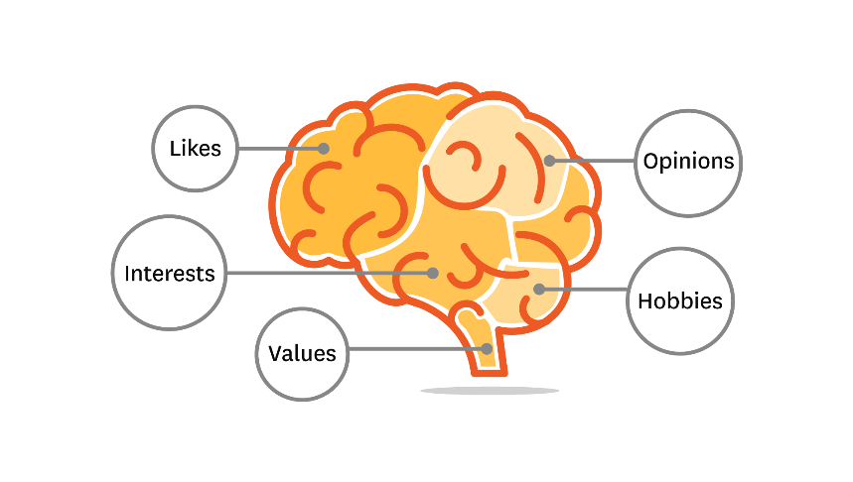

Psychographic segmentation is similar to demographic segmentation, but it deals with characteristics that are more mental and emotional.

These attributes may not be as easy to observe as demographics, but they can give you valuable insight into your audience’s motives, preferences and needs. Understanding these aspects of your audience can help you to create content that appeals to them more effectively. Some examples of psychographic characteristics include personality traits, interests, beliefs, values, attitudes and lifestyles.

# Consumer Motivation

Let's see the reasons why people actually buy!

## Practical Needs

People may be motivated to buy a product or service to fulfil a practical need or solve a problem. For example, a person might buy a new computer because their old one is no longer functioning properly.

**.**

Businesses can appeal to this type of motivation by **highlighting the functional benefits of their product or service** and showing how it can help customers solve a particular problem or need.

## Emotional Desires

Customers sometimes buy a product **to fulfil an emotional desire or meet a personal goal**. For example, a person might buy a new outfit to feel confident or to celebrate a special occasion. In this case, it is the best for businesses to **show how it can help customers fulfil their emotional desires or goals.**

## Social Pressures

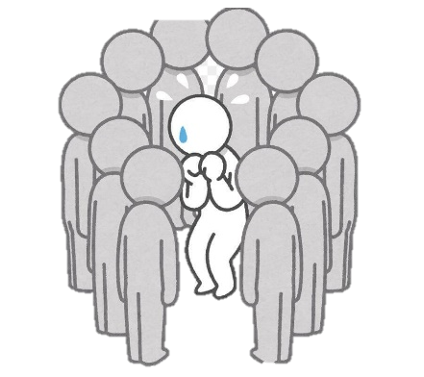It is also possible that customers are motivated to buy a product or service **to fit in with a certain social group or to conform to societal norms**. For example, a person might buy a certain brand of clothing because it is popular among their peer group. It is often driven by **a desire to fit in or be accepted by others.**

So, the best practice for businesses to **showcase the social benefits of their product or service** and explaining how it can help customers fit in with a particular social group or conform to societal norms.

## Status or Prestige

Sometimes people also buy a product **to enhance their social status or reputation.** A person might buy a luxury brand of clothing to signal their success or status. The underlying reason for this motivation is **a desire to gain respect or admiration from others.**

If you want to take advantage of this motivation, **highlight the status or prestige that your product can bring** and showing how it can help customers enhance their social status or reputation.

## Convenience

Convenience is also an important buying motivation which means a product or service is bought because it **saves them time or effort.** A person might buy a pre-made meal from a grocery store because it is more convenient than cooking from scratch.

Let the customers know about the convenience of the product or service and show how it can **help customers save time or effort** help businesses to increase sales thanks to this buying motivation.

## Cost

Without denial, cost is a crucial buyer motivation as people like to buy a product or service **that offers the best value for their money.**

For example, a person might compare prices at different retailers to find the best deal on a particular product. This motivation is triggered by **a wish to get the most for one's money.**

If you showcase the cost-effectiveness of your product and explain how it offers the best value for the customer's money, this kind of motivation works wonders for your business

## Scarcity

**FOMO Marketing** is built on scarcity buying motivation. People may be motivated to buy a product or service that is in short supply or limited edition. **Having a limited time to buy a product also triggers buying behaviour.**

Let's say a person sees a [limited time offer](https://popupsmart.com/blog/limited-time-offers) while browsing on your website. They will be triggered to buy your product in order not to miss out on the opportunity.

Businesses can appeal to this type of motivation by emphasizing on the scarcity of their product, and **creating a sense of urgency or exclusivity.**

## Health

People are also motivated to purchase something that will benefit their physical or mental health, such as a gym membership or healthy food.

This motivation often stems from a wish **to take care of oneself or prevent future health problems.**

You can attract this type of motivation by emphasizing the health benefits of their product or service and **demonstrating how it can help customers maintain or improve their health.**

## Impulse

**"Spontaneous shopping"** or **"whim-buying"** can be driven by various factors, such as feeling emotionally charged, feeling a sense of urgency, or wanting instant gratification.

You can appeal to this motivation by creating an exciting or emotional experience for customers, or **by offering "flash sales" or "deal-of-the-day" promotions.**

Bibliography and References

* [TED-Ed]. (2016, Aug 29). The paradox of value - Akshita Agarwal [Video File]. Retrieved from <https://youtu.be/e7S8jWh6AEs>
* Bloomenthal, A.(2019, May 23). Marginal Utility. Retrieved from <https://www.investopedia.com/terms/m/marginalutility.asp>
* Human Behaviour Models. Retrieved from <https://repository.up.ac.za/bitstream/handle/2263/29162/02chapter2.pdf?sequence=3>
* Analysis of consumer behaviour. [Unit 2: Consumer Theory | Principles of Microeconomics | Economics | MIT OpenCourseWare](https://ocw.mit.edu/courses/14-01sc-principles-of-microeconomics-fall-2011/pages/unit-2-consumer-theory/)
* Economic Theories. Cardinal and Ordinal Utility Analysis. Retrieved from <https://umeschandracollege.ac.in/pdf/study-material/economics/Theory-of-Consumer-Behaviour.pdf>
* Metu, A. G. (2017). Consumer behaviour: The ordinal approach. In O. K. Obi & C. Kalu, principles of economics (1st ed.)
* Influential Factors. Retrieved from <https://fastpayltd.co.uk/blog/consumer-behaviour-theory-how-has-it-changed/#:~:text=Consumer%20behaviour%20theory%20is%20the,consumer%20will%20make%20a%20purchase>.
* Marketing Research Techniques. Consumer Behavioural Research. Retrieved from <https://smallbusiness.chron.com/consumer-behavior-research-methods-70706.html>
* Segmenting the Market and Customer. Retrieved from <https://www.lotame.com/>
* Buyers Motivation. Consumer Satisfaction. Retrieved from <https://popupsmart.com/blog/buyer-motivation>
* Images from Royality-Free sources. <https://pixabay.com/>